***JAYPEE INSTITUTE OF***

***INFORMATION TECHNOLOGY***

***PREDICTING STOCKS: A PROBABILITY APPROACHES***

**Submitted By (B6 BATCH):**



|  |  |
| --- | --- |
| **TANUSH** | **22103157** |
| **SAUMIL GUPTA** | **22103179** |
| **KARAN NAVEEN SOOD** | **22103180** |
|  |  |



***INTRODUCTION***



The stock market serves as a dynamic arena where investors navigate

the uncertainties of financial markets in pursuit of profitable

opportunities. Within this landscape, the ability to predict stock prices

accurately holds immense value, offering potential for informed

decision-making and risk management. This project delves into the

realm of predictive modeling in the stock market, leveraging

probability-based approaches to forecast

stock prices.

* **Background**

Traditionally, stock market analysis relied heavily on historical data,

technical indicators, and fundamental analysis to inform investment

decisions. However, with advancements in computational techniques and

the growing availability of data, probabilistic methods have gained

prominence for their ability to capture the inherent uncertainty and

complexity of financial markets.

* **Objectives**

The primary objective of this research is to explore the application of probability-based methods in predicting stock prices. By delving into fundamental probability concepts and leveraging predictive modeling techniques, the aim is to develop robust models capable of forecasting stock price movements with a high degree of accuracy. Additionally, this project

seeks to evaluate the performance of various predictive models and identify their strengths and limitations.

* **Scope of the Project**

This project encompasses a comprehensive examination of probability fundamentals, including probability distributions, expected value, variance,

and conditional probability. It also extends to exploring the role of

probability in stock market analysis, encompassing risk assessment,

portfolio management, and decision-making processes. Furthermore, the

project will involve practical implementation, including data collection, preprocessing, model development, and evaluation. While the focus

remains on stock price prediction, the insights gained from this research

have broader implications for financial markets and predictive analytics.

***PROBABILITY IN STOCK MARKET ANALYSIS***



Understanding the role of probability in stock market analysis is essential

for navigating the complexities of financial markets and making informed investment decisions. This section explores how probability concepts are

applied in analyzing the stock market, including its overview, significance

in finance, and practical applications in risk management.

* **Overview of Stock Market**

The stock market serves as a vital platform where investors trade securities, including stocks, bonds, and derivatives. It is characterized by dynamic

price movements influenced by various factors such as economic indicators, company performance, and investor sentiment. Analyzing the stock market involves assessing these factors to anticipate future price movements and identify profitable opportunities.

* **Role of Probability in Finance**

Probability plays a fundamental role in finance by providing a framework

for quantifying uncertainty and risk. In the context of stock market analysis, probability theory is utilized to model the likelihood of different market outcomes and assess the associated risks and returns. By applying

probabilistic methods, investors can make rational decisions based on the probabilities of various scenarios.

* **Probability-Based Metrics in Stocks**

Several probability-based metrics are employed in analyzing stocks to

gauge their performance and potential future movements. These metrics

include measures such as volatility, correlation, beta, and option pricing

models. Volatility measures the degree of variation in a stock's price over

time, providing insights into its riskiness. Correlation quantifies the

relationship between the returns of different stocks, while beta measures a stock's sensitivity to market movements. Option pricing models, such as the Black-Scholes model, use probability theory to estimate the fair value of

options contracts.



* **Applications in Risk Management**

Risk management is a crucial aspect of stock market analysis, aiming to minimize potential losses and maximize returns. Probability-based approaches are integral to risk management strategies, allowing investors to quantify and mitigate risks effectively. Techniques such as value at risk (VaR), stress testing, and Monte Carlo simulation utilize probability theory to assess the likelihood of adverse market events and their potential impact on investment portfolios. By incorporating probabilistic risk models, investors can optimize their portfolio allocations and achieve their financial objectives while managing risk exposure.

Understanding the role of probability in stock market analysis provides investors with a systematic framework for evaluating investment opportunities, assessing risks, and making informed decisions in dynamic financial markets. By leveraging probability-based approaches, investors can navigate market uncertainties with greater confidence and achieve sustainable long-term returns.

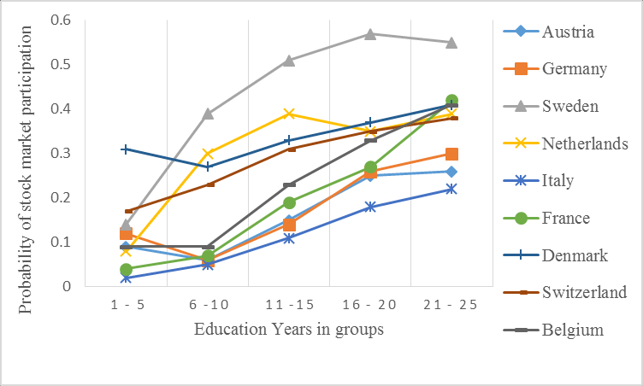



* **Basic Concepts**

Probability theory deals with quantifying uncertainty and analyzing random phenomena. At its core are fundamental concepts such as events, outcomes, and sample spaces. Events represent outcomes of interest, while outcomes are the possible results of an experiment. The sample space encompasses all possible outcomes of an experiment. Probability is then defined as the likelihood of an event occurring, typically expressed as a value between 0 and 1.

* **Probability Distributions**

Probability distributions describe the likelihood of various outcomes in a random experiment. Common distributions include the uniform distribution, normal distribution, binomial distribution, and Poisson distribution. Each distribution has its own characteristics and parameters that dictate the shape and spread of its probability density function. Understanding these distributions is crucial for modeling random variables and making probabilistic predictions.

* **Expected Value and Variance**

The expected value, also known as the mean, represents the average outcome of a random variable over multiple trials. It is calculated by multiplying each possible outcome by its probability of occurrence and summing the results. Variance, on the other hand, measures the spread or dispersion of a random variable's distribution around its expected value. A low variance indicates that the values are clustered closely around the mean, while a high variance signifies greater variability.

* **Conditional Probability**

Conditional probability quantifies the likelihood of an event occurring given that another event has already occurred. It is denoted as P(A|B), representing the probability of event A occurring given that event B has occurred. Conditional probability plays a crucial role in stock market analysis, particularly in assessing the likelihood of specific market movements based on past performance or external factors. Understanding conditional probability enables analysts to make more informed predictions and decisions in dynamic financial markets.

***Probability Fundamentals***

]



***Predictive Modeling Techniques***

Predictive modeling techniques are indispensable tools for forecasting

future trends and making informed decisions in various domains, including

stock market analysis. This section explores five key predictive modeling

techniques commonly used in predicting stock prices: Linear Regression,

Time Series Analysis, Monte Carlo Simulation, Bayesian Inference, and

Machine Learning Algorithms.

* **Linear Regression**

Linear regression is a statistical technique used to model the relationship

between a dependent variable and one or more independent variables. In

the context of stock market analysis, linear regression can be applied to

identify patterns and relationships between stock prices and relevant factors

such as economic indicators, company performance metrics, and market

sentiment. By fitting a linear regression model to historical data, analysts

can make predictions about future stock price movements based on the

observed trends.

* **Time Series Analysis**

Time series analysis involves studying the pattern, trend, and seasonality of

data collected over time. In stock market analysis, time series analysis is

used to model and forecast stock prices based on historical price data.

Techniques such as autoregressive integrated moving average (ARIMA)

models, exponential smoothing, and Fourier analysis are commonly

employed to analyze time series data and make predictions about future price movements.

* **Monte Carlo Simulation**

Monte Carlo simulation is a computational technique used to simulate a

wide range of possible outcomes by generating random samples from

probability distributions. In stock market analysis, Monte Carlo simulation

can be used to model the behavior of financial assets and portfolios under

different market conditions. By simulating numerous scenarios based on

historical data and probabilistic assumptions, analysts can assess the

potential risks and returns associated with various investment strategies

and make informed decisions accordingly.



* **Bayesian Inference**

Bayesian inference is a statistical method used to update beliefs or make predictions based on prior knowledge and new evidence. In stock market analysis, Bayesian inference can be applied to incorporate new information into predictive models and refine forecasts over time. By combining historical data with Bayesian priors and updating posterior probabilities using observed market data, analysts can make more accurate predictions about future stock price movements and adjust their investment strategies accordingly.

* **Machine Learning Algorithms**

Machine learning algorithms, including supervised learning, unsupervised learning, and reinforcement learning, offer powerful tools for predictive modeling in stock market analysis. Supervised learning algorithms, such as decision trees, random forests, support vector machines, and neural networks, can be trained on historical data to make predictions about future stock prices. Unsupervised learning algorithms, such as clustering and dimensionality reduction, can help identify patterns and anomalies in stock market data. Reinforcement learning algorithms can be used to develop adaptive trading strategies that optimize portfolio performance based on real-time market feedback.

By leveraging these predictive modeling techniques, analysts can gain valuable insights into stock market dynamics, anticipate future trends, and make informed decisions to achieve their investment objectives. Each technique offers unique strengths and capabilities, allowing analysts to tailor their approach to the specific requirements of the problem at hand and extract actionable insights from complex and dynamic financial data.



***Data: The Foundation of Probability sc***

Data collection and preprocessing are critical steps in the predictive modeling process, ensuring that the data used for analysis is accurate, relevant, and

suitable for modeling purposes. This section explores the key components of

data collection and preprocessing, including data sources, data cleaning, and

feature engineering.

* **Data Sources**

In stock market analysis, data can be sourced from a variety of sources,

including financial databases, market exchanges, and third-party vendors.

These sources provide access to historical price data, company financials,

economic indicators, and other relevant information necessary for modeling

stock prices. Additionally, alternative data sources such as social media

sentiment, news articles, and satellite imagery can provide valuable insights

into market trends and investor sentiment.

* **Data Cleaning**

Once collected, raw data often requires cleaning and preprocessing to remove

errors, inconsistencies, and missing values. Data cleaning techniques may

include handling missing data through imputation or deletion, removing

outliers, correcting errors, and standardizing data formats. By ensuring the

integrity and quality of the data, analysts can minimize the risk of biases and inaccuracies in their predictive models.

* **Feature Engineering**

Feature engineering involves selecting, transforming, and creating features from

raw data to improve the predictive performance of models. In stock market

analysis, features may include historical stock prices, trading volumes,

technical indicators, fundamental metrics, economic indicators, and sentiment

scores. Feature engineering techniques such as lagging, differencing, scaling,

and dimensionality reduction can enhance the predictive power of models by capturing relevant patterns and relationships in the data.



***Evaluation Metrics***

Evaluation metrics are essential tools for assessing the performance of predictive models in predicting stock prices. This section discusses four key evaluation

metrics: Mean Absolute Error (MAE), Mean Squared Error (MSE), Root Mean Squared Error (RMSE), and Accuracy, Precision, and Recall.

* **Mean Absolute Error (MAE)**

MAE measures the average absolute difference between predicted and actual

values. It provides a straightforward measure of the model's prediction accuracy,

with lower values indicating better performance. MAE is particularly useful for interpreting errors in the same units as the original data, making it easy to

understand and compare across different models.

* **Mean Squared Error (MSE)**

MSE measures the average squared difference between predicted and actual

values. It penalizes larger errors more heavily than MAE, making it sensitive to outliers in the data. MSE is commonly used in regression analysis and provides a measure of the model's precision in predicting continuous variables.

* **Root Mean Squared Error (RMSE)**

RMSE is the square root of the MSE and represents the standard deviation of prediction errors. It provides a measure of the average magnitude of errors in the model's predictions, with lower values indicating better performance. RMSE is particularly useful for comparing models with different scales of prediction

errors.

* **Accuracy, Precision, and Recall**

Accuracy, precision, and recall are evaluation metrics commonly used in classification tasks. Accuracy measures the proportion of correct predictions out of the total number of predictions. Precision measures the proportion of true positive predictions out of all positive predictions, while recall measures the proportion of true positive predictions out of all actual positive instances. These metrics are useful for assessing the performance of classification models in predicting stock price movements.



***Case Study: Predictive Analysis of Stock Prices***

This section presents a case study on the predictive analysis of stock prices,

including a description of the dataset, model implementation, and results and

analysis.

* **Description of Dataset**

The dataset used in the case study contains historical stock price data, along

with relevant features such as trading volumes, technical indicators, and

economic indicators. The dataset is preprocessed and cleaned to remove

errors, inconsistencies, and missing values, ensuring the integrity and

quality of the data for modeling purposes.

* **Model Implementation**

Several predictive models are implemented using the dataset, including

linear regression, ARIMA, Monte Carlo simulation, Bayesian networks,

and neural networks. Each model is trained on historical data and evaluated

using appropriate evaluation metrics to assess its predictive performance.

* **Results and Analysis**

The results of the predictive models are analyzed to identify patterns, trends,

and relationships in the data. The performance of each model is evaluated

using evaluation metrics such as MAE, MSE, RMSE, accuracy, precision,

and recall. Insights gained from the analysis are used to draw conclusions

and make recommendations for further research.



The stock market may be a whirlwind of uncertainty, but by wielding the power of probability, we can transform educated guesses into informed strategies. This project has unveiled a treasure trove of probabilistic techniques – from simulations that model countless futures to dynamic Bayesian updates that adapt to ever-changing information. We've seen how transforming raw data into a probabilistic landscape empowers us to build robust models, evaluate their accuracy with a keen eye for error, and ultimately, navigate the financial world with a sense of grounded confidence.

The journey doesn't end here. The future beckons with the promise of even more sophisticated probabilistic tools, fueled by an ever-expanding ocean of financial data. As we harness these advancements, ethical considerations must remain paramount. We must ensure responsible use of these powerful tools, fostering fairness and transparency in the markets.

In conclusion, embracing a probabilistic approach to stock market analysis isn't just about predicting prices; it's about harnessing the power of uncertainty to make informed decisions and achieve long-term financial goals. As we move forward, let probability be our compass, guiding us through the complexities of the market and towards a brighter financial future.



# CONCLUSION

.

# Discover Stock Prediction and Analysis Solutions



Welcome to our platform, where cutting-edge technology meets expert analysis

to provide you with unparalleled insights into the world of stock market

prediction. Whether you're a seasoned investor or just starting your journey in

the financial markets, our platform offers a comprehensive suite of tools and resources to help you make informed investment

decisions.

Explore real-time predictions generated by sophisticated algorithms,

customizable analysis tools, interactive charts and graphs, educational

resources, and a vibrant online community. With our user-friendly interface and

continuous improvement, we're here to help you achieve your financial goals

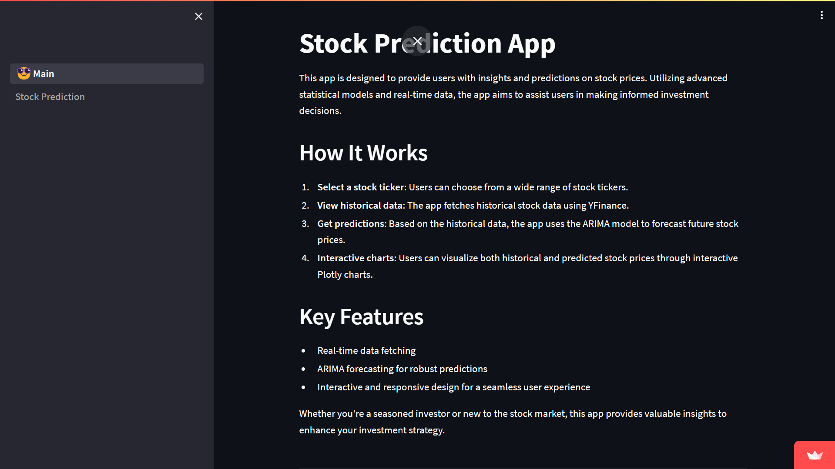with confidence and precision.

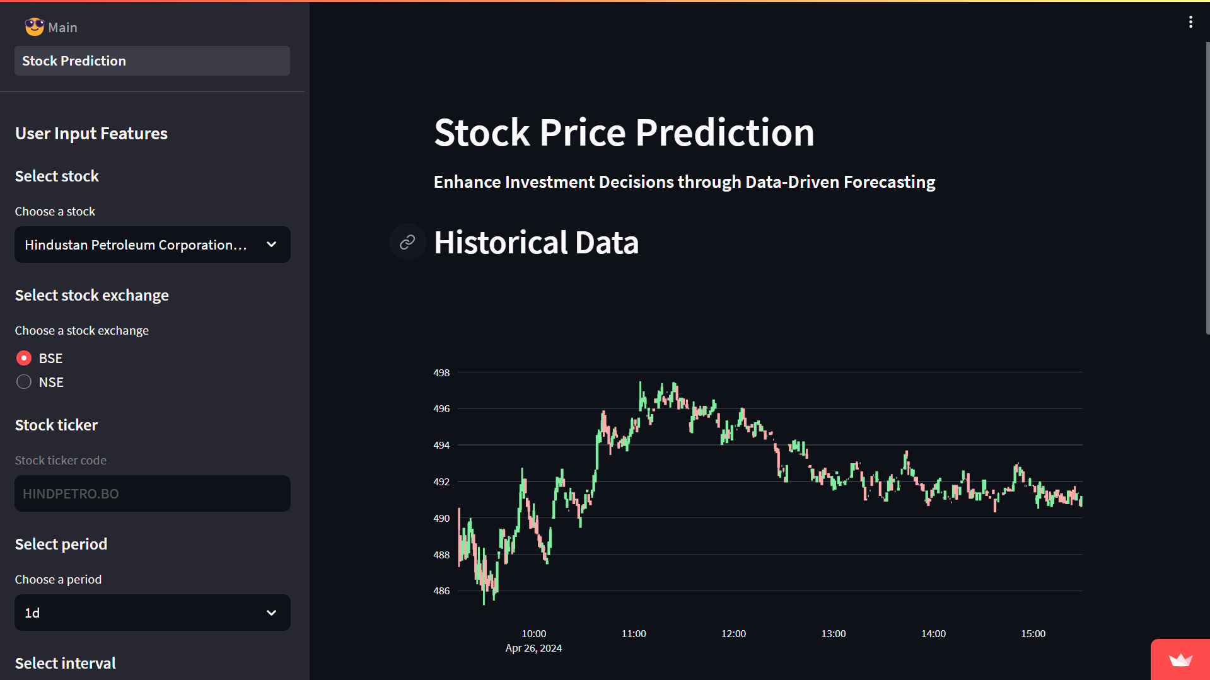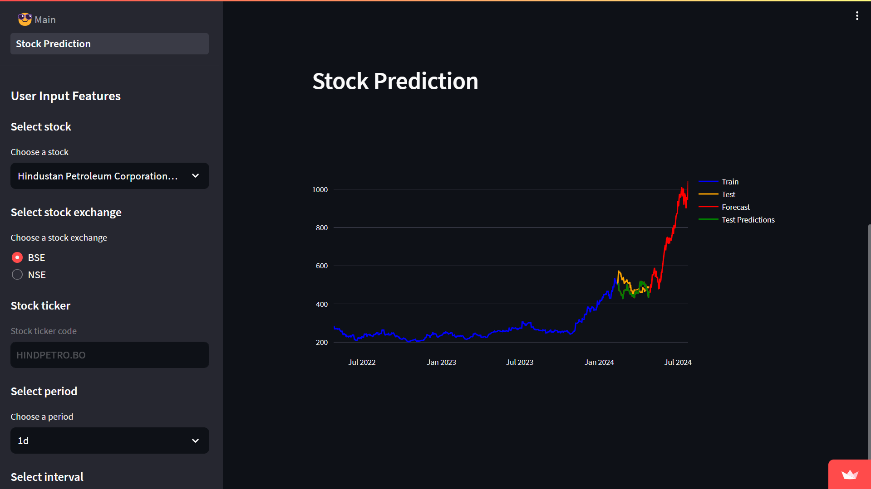



**References**

1. <https://www.tickertape.in>
2. <https://iknowfirst.com>
3. <https://streamlit.io>



**Table of Contents**

**1.Introduction ---------------------------------------------------------------------------------------------------- 1**

**Background**

**Objectives**

**Scope of the Project**

**2.Probability Fundamentals----------------------------------------------------------------------------------- 2**

**Basic Concepts**

**Probability Distributions**

**Expected Value and Variance**

**Conditional Probability**

**3.Probability in Stock Market Analysis-------------------------------------------------------------------- 3-4**

**Overview of Stock Market**

**Role of Probability in Finance**

**Probability-Based Metrics in Stocks**

**Applications in Risk Management**

**4.Predictive Modeling Techniques-------------------------------------------------------------------------- 5-6**

**Linear Regression**

**Time Series Analysis**

**Monte Carlo Simulation**

**Bayesian Inference**

**Machine Learning Algorithms**

**5.Data : The Foundation of Probability--------------------------------------------------------------------- 7**

**Data Sources**

**Data Cleaning**

**Feature Engineering**

**6.Evaluation Metrics-------------------------------------------------------------------------------------------- 8**

**Mean Absolute Error (MAE)**

**Mean Squared Error (MSE)**

**Root Mean Squared Error (RMSE)**

**Accuracy, Precision, and Recall**

**8.Case Study: Predictive Analysis of Stock Prices-------------------------------------------------------- 9**

**Description of Dataset**

**Model Implementation**

**Results and Analysis**

**9.Discover Stock Prediction and Analysis Solutions--------------------------------------------------- 10-11**

**10.Conclusion------------------------------------------------------------------------------------------------------- 12**

**Summary of Findings**

**Implications for Stock Market Prediction**

**Recommendations for Further Research**

**11References------------------------------------------------------------------------------------------------------ 13**

